Salesforce Development and Backend Configurations
2.1 Salesforce Development
Introduction
Salesforce is a leading cloud-based Customer Relationship Management (CRM) platform that enables organizations to build secure, scalable, and highly automated business applications without extensive programming. It provides powerful declarative development tools such as Custom Objects, Flows, Validation Rules, Approval Processes, Reports, Dashboards, and Lightning Components, allowing developers and administrators to create enterprise-grade applications efficiently.
In this project, Salesforce serves as the foundation for developing the AI-Enabled Student Admission System. The platform was used to design a centralized application that manages student records, course information, enrollment details, approvals, payment tracking, and AI-assisted decision-making. By using Salesforce's declarative features, the application eliminates repetitive manual tasks while ensuring data accuracy, security, and business process automation.
The Salesforce development process focused on creating a structured data model, configuring object relationships, implementing business rules, and integrating automation features that support the complete admission lifecycle.

📷 Figure 2.1 – Salesforce Lightning Setup
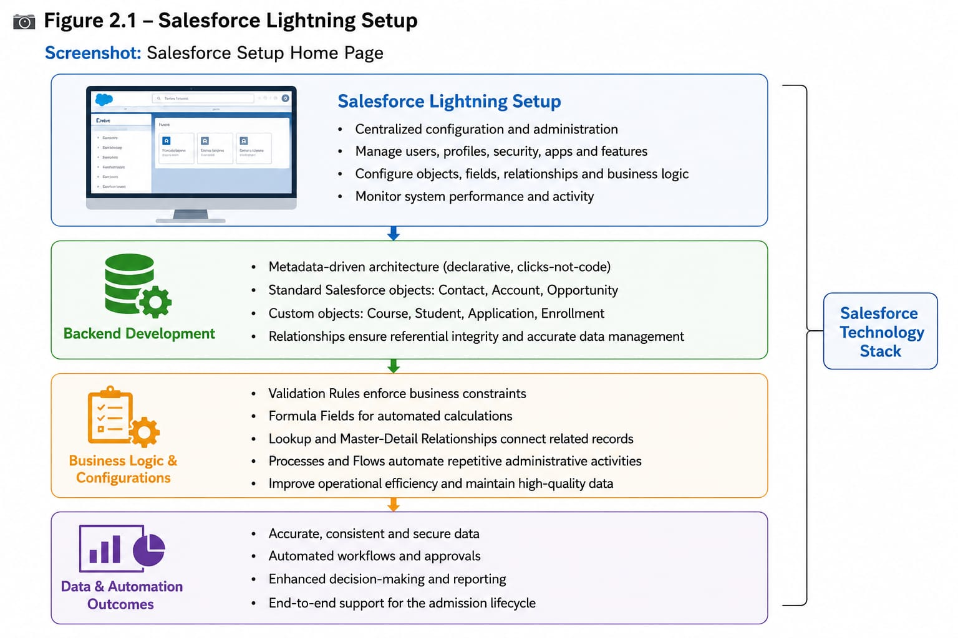

2.2 Backend Development
The backend of the AI-Enabled Student Admission System was developed using Salesforce's metadata-driven architecture. Instead of traditional programming, Salesforce stores application configurations as metadata, allowing administrators to customize business processes without writing complex code.
The backend consists of standard Salesforce objects such as Contact, Account, and Opportunity, together with custom objects including Course and Student Enrollment. Relationships between these objects ensure accurate data management while maintaining referential integrity throughout the application.
Validation Rules enforce business constraints, Formula Fields perform automatic fee calculations, Lookup and Master-Detail Relationships connect related records, while Approval Processes and Flows automate repetitive administrative activities. These backend configurations improve operational efficiency and maintain high-quality admission data.

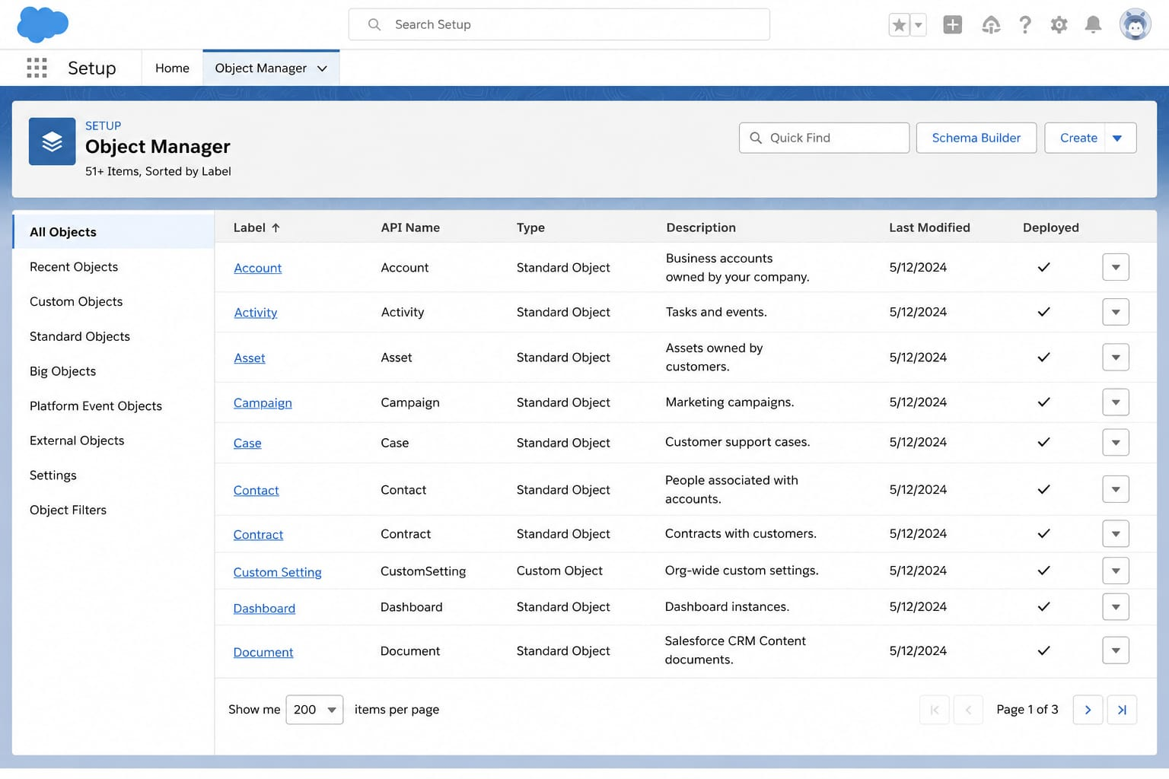

2.3 Salesforce Configurations
Salesforce configurations play a critical role in implementing business requirements without writing custom code. Throughout the project, multiple configuration components were developed to automate admission workflows, maintain data integrity, improve user productivity, and integrate AI capabilities.
The major configurations implemented include:
- Custom Objects
- Custom Fields
- Relationships
- Validation Rules
- Formula Fields
- Lookup Relationships
- Master-Detail Relationships
- Approval Processes
- Email Templates
- Email Alerts
- Record-Triggered Flows
- Scheduled Flows
- Screen Flows
- Agentforce Configuration
- Prompt Templates
- Lightning Application
- Dynamic Forms
These configurations together create a secure, scalable, and intelligent admission management application.

📷 Figure 2.3 – Salesforce Architecture
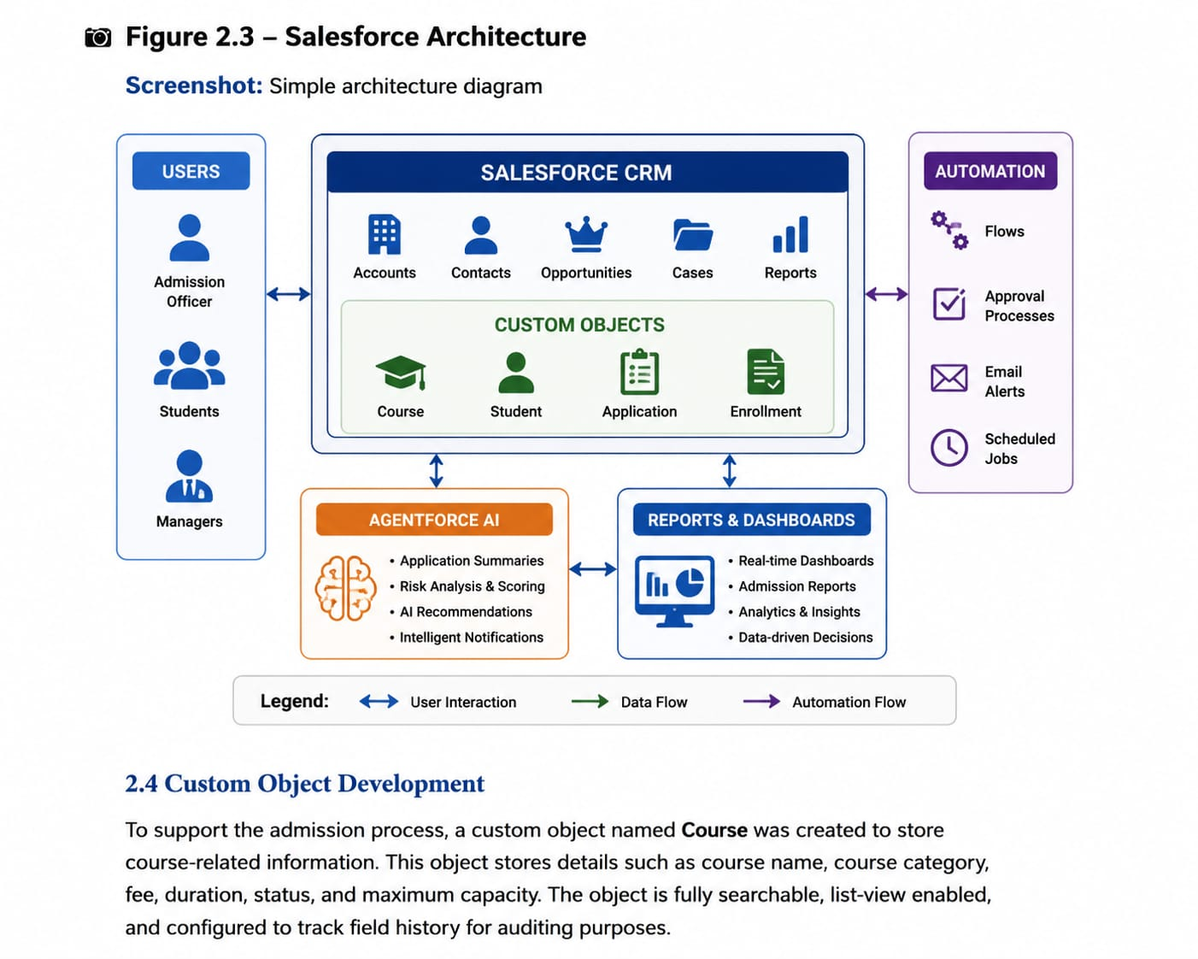

2.4 Custom Object Development
To support the admission process, a custom object named Course was created to maintain all course-related information. This object stores details such as course name, course code, category, fee, duration, status, and maximum capacity. The object is fully searchable, report-enabled, and configured to track field history for auditing purposes.
A separate Student Enrollment custom object was developed to record enrollment transactions between students and courses. This object establishes Master-Detail relationships with the Contact and Course objects, ensuring strong data consistency and enabling roll-up summaries if required.
These custom objects provide the foundation for managing admissions within the Salesforce application.

📷 Figure 2.4 – Course Custom Object
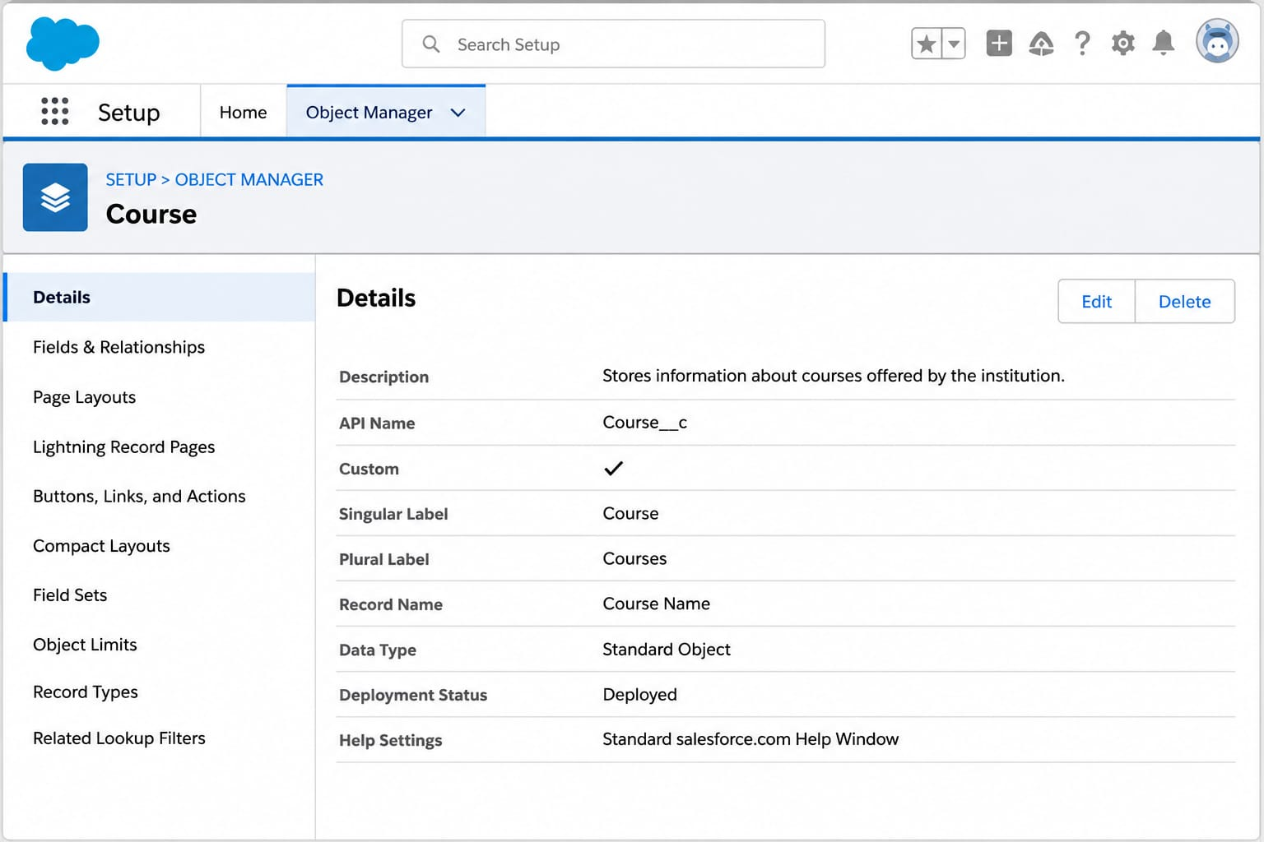

📷 Figure 2.5 – Student Enrollment Object
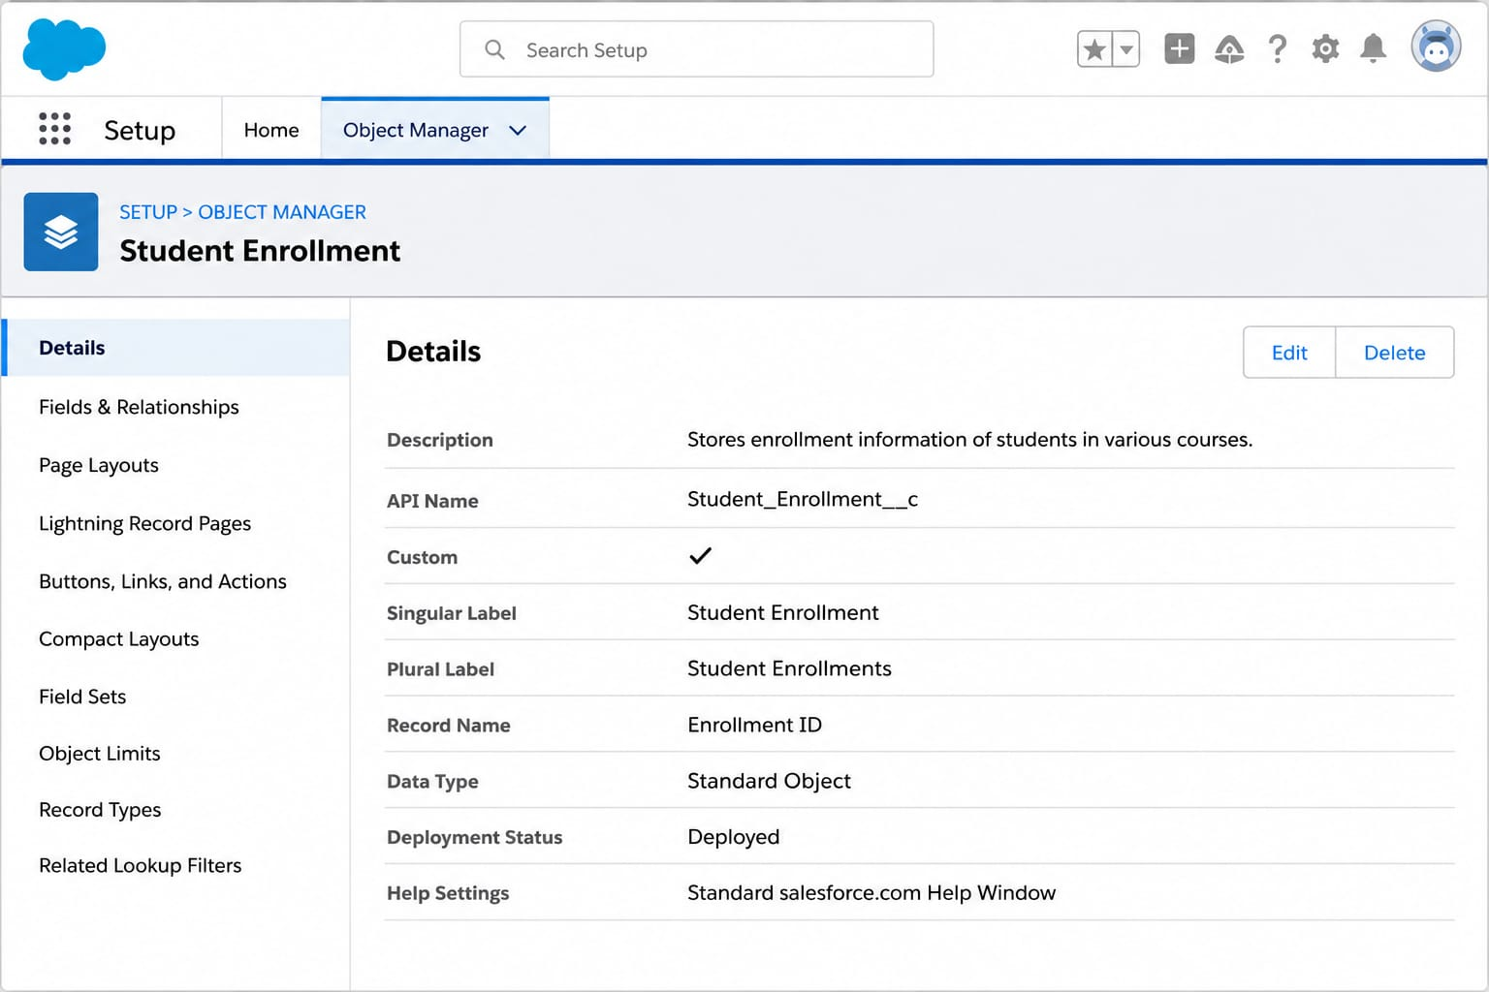
t

2.5 Course Object Creation
The Course object was designed to maintain complete information about all available courses offered by the institution. Each course record contains details such as course code, category, fee structure, duration, capacity, and active status.
The object enables counselors to manage course information efficiently while supporting enrollment automation and reporting.
Course Object Features
- Custom Object
- Text Record Name
- Reports Enabled
- Search Enabled
- Track Field History Enabled
- Custom Tab Created

📷 Figure 2.6 – Course Object Creation
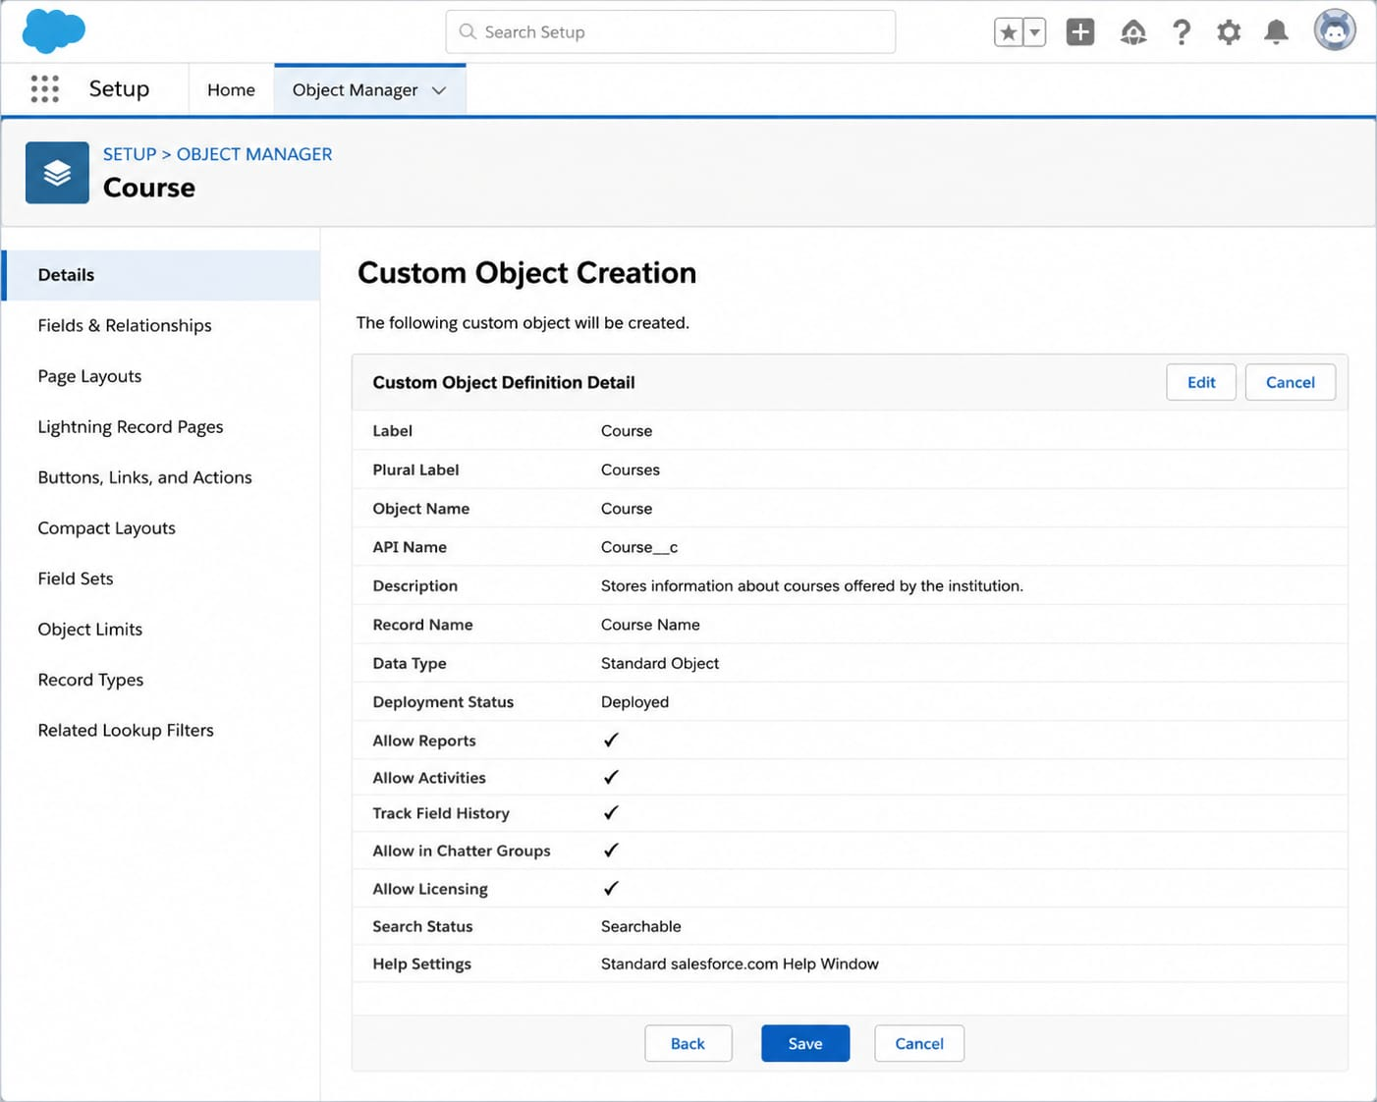

2.6 Course Object Tab Configuration
After creating the Course object, a custom Lightning tab was configured to allow users to access course records directly from the application navigation bar. The tab was assigned an appropriate icon and made available to relevant profiles while excluding unnecessary applications.
This improves navigation and provides easy access to course management features.

📷 Figure 2.7 – Course Tab
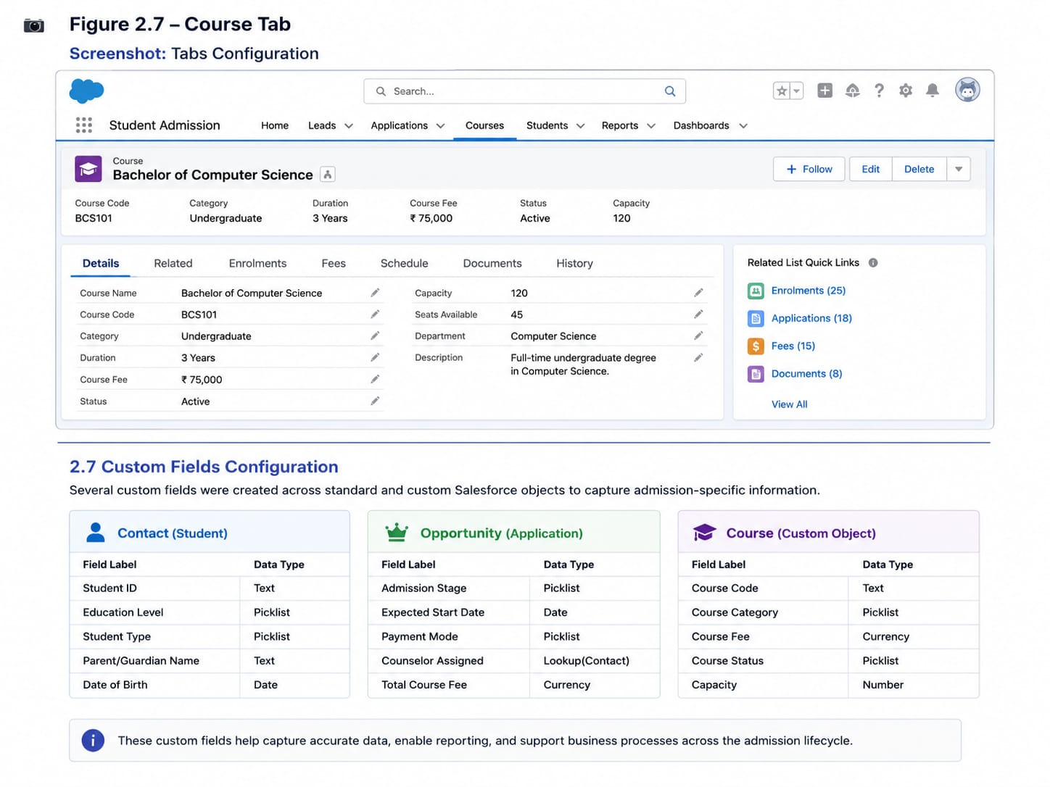

2.7 Custom Fields Configuration
Several custom fields were created across standard and custom Salesforce objects to capture admission-specific information.
The Contact object was extended with Student ID, Education Level, and Student Status fields.
The Opportunity object includes Admission Stage, Expected Start Date, Payment Status, Counselor Assigned, and Total Course Fee.
The Course object contains Course Code, Course Category, Course Fee, Course Duration, Course Status, and Capacity.
The Student Enrollment object stores enrollment date, discount percentage, approval status, payment status, and automatically calculates the final payable amount using a Formula Field.
These fields collectively support accurate admission processing and reporting.
Figure 2.8 – Custom Fields
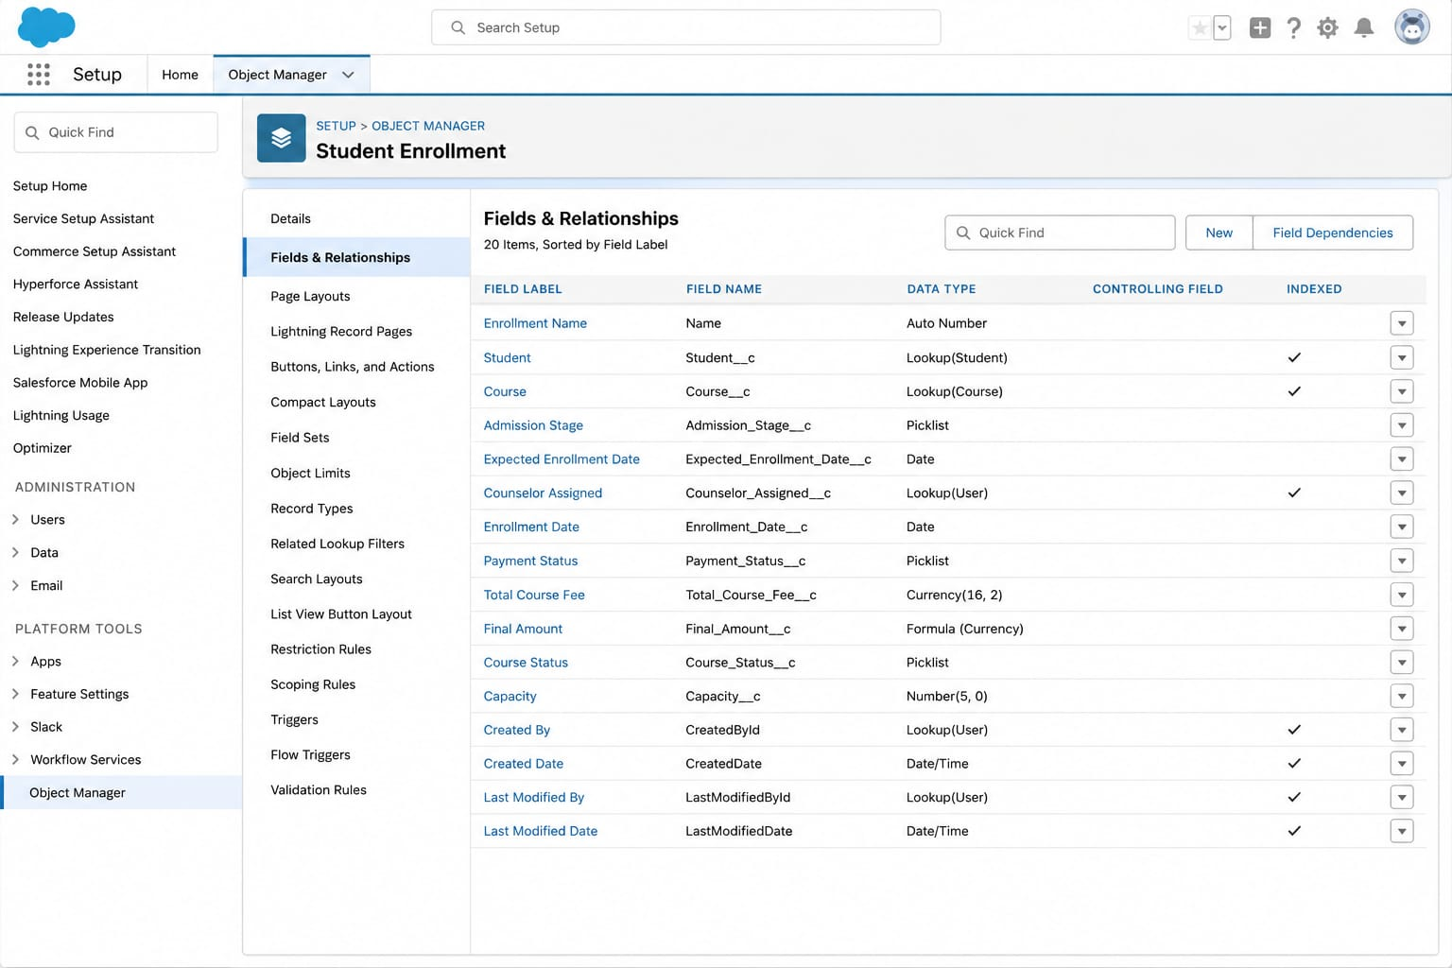

Team Information
Team ID : SWTID-2026-9625
Team Size : 5
Team Leader : Gayathri Pemmanaboyidi
Team member : Anitha Kumari Seekolu
Team member : Aditya Vardhan Katta
Team member : Jaswanth Srikar Addanki
Team member : Sontenam Santosh Venkat Charan

S.No | Role | Full Name | Email ID
1 | Team Lead | Gayathri Pemmanaboyidi | gayathridevipemmanaboyidi@gmail.com
2 | Team Member | Anitha Kumari Seekolu | seekoluanitha13@gmail.com
3 | Team Member | Aditya Vardhan Katta | kattaadityavardhan@gmail.com
4 | Team Member | Jaswanth Srikar Addanki | jaswanthsrikar56@gmail.com
5 | Team Member | Sontenam Santosh Venkat Charan | ssvcharan414@gmail.com

